*Kevin Cao & Dhruvit Naik*

*Project#3: HVDC*

ELC 470: Power Systems

Problem: Familiarize ourselves with three-phase circuits and high-voltage dc transmission.

The first task was to connect the different pieces of the system. The three-phase generator was connected to the diode rectifier. That subsystem was connected to the dc transmission line. Finally, the three-phase inverter and resistive load was connected. We then calculated the undefined values. Below is PSpice Schematic.

Step #3: PSpice Circuit

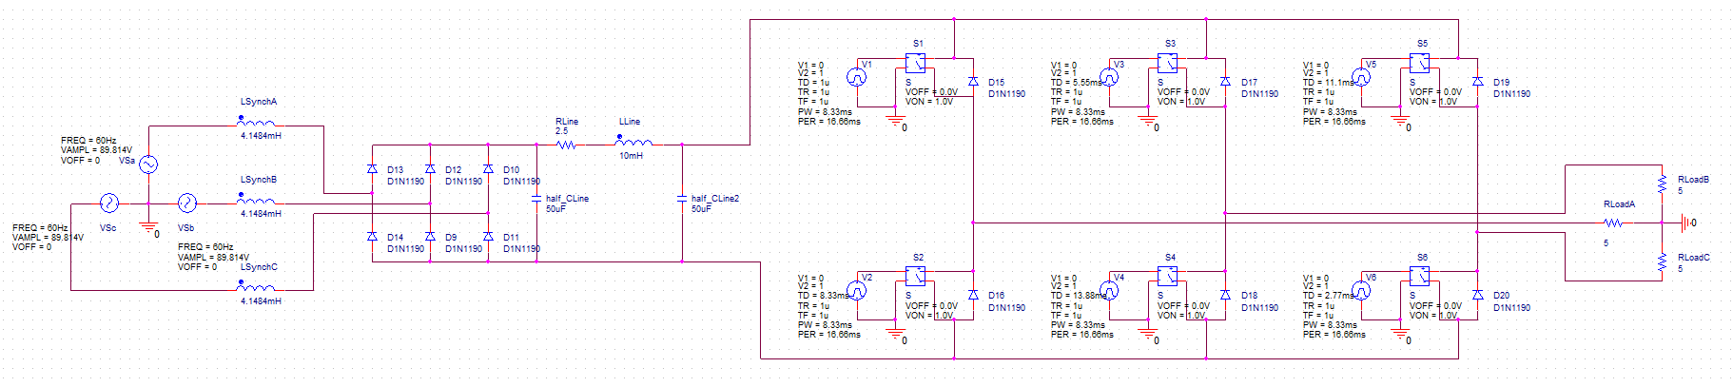

Figure 1: Circuit of HVDC Transmission System

Step #4: Transient Analysis of Terminal Voltages

Figure 2: Three-Phase Generator Terminal Voltages (A, B, C) vs. Time

Step #5: Calculate the RMS of Phase a Generator Terminal

Step #6: Transient Analysis of Sending and Receiving-End Line

Figure 3: Sending and Receiving-End Line Terminal Voltages vs Time

Step #7: Calculate the ripple in the Sending and Receiving

Step #8: Calculate the average in the Sending and Receiving

In order to calculate the average, we found the sum of voltage \* time step and divided the result by the period (0.005).

Step #10: Next Page

Step #11:

When the resistive load is increased, the generator terminal voltages resemble a pure sinusoidal wave. In addition, more current is being drawn to the load. Also the sending and receiving voltages are identical waves. There is no loss between them.

Step #10:

We increased the resistive load from 50Ω to 500kΩ per phase. Then reexamined the generator and sending & receiving terminal voltages.

Figure 4: Three-Phase Generator Terminal Voltages (A, B, C) vs. Time with 500kΩ load

Figure 5: Sending and Receiving-End Line Terminal Voltages vs Time with 500kΩ load

Step #13:

Figure 6: Load Voltages (A, B, C) vs. Time

Step #14:

Figure 7: Generator and Load Voltages/Currents for Phase A vs. Time

Step #15: RMS magnitude of voltages and currents below.

Step #16: Read Power output of generator and load.

Step #17: Efficiency of transmission system.

Step #18:

For the HVDC transmission line, as resistivity increases the efficiency follows a negative log trend. While the 3-Phase system resistivity increase the efficiency decreases linearly. Thus the HVDC is much more stable in terms of efficiency vs line resistivity.

Step #19: Fourier Analysis

Next Page:

Figure 8-11: Comparison of Waveforms and Fundamental Components of Generator and Load Terminal Voltages/Currents for Phase A vs. Time

Step #20: Define Phasors for fundamental waveform. Note we shifted the phase angles to assume generator voltage has an angle of zero.

Step #21: Complex Power

Step #22:

When comparing the power calculated in step #21 and #16, the results to do not match up. This is because we are only considering the first harmonic in #21. While #16 has the sum of all harmonics.

Step #23:

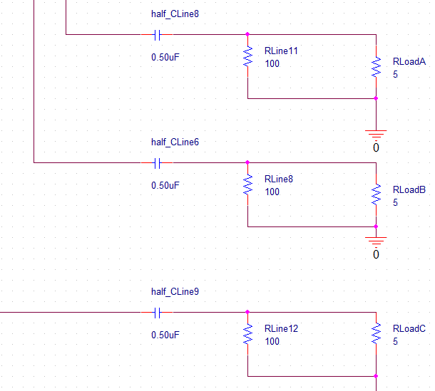

Figure 12: Filter Design for Load

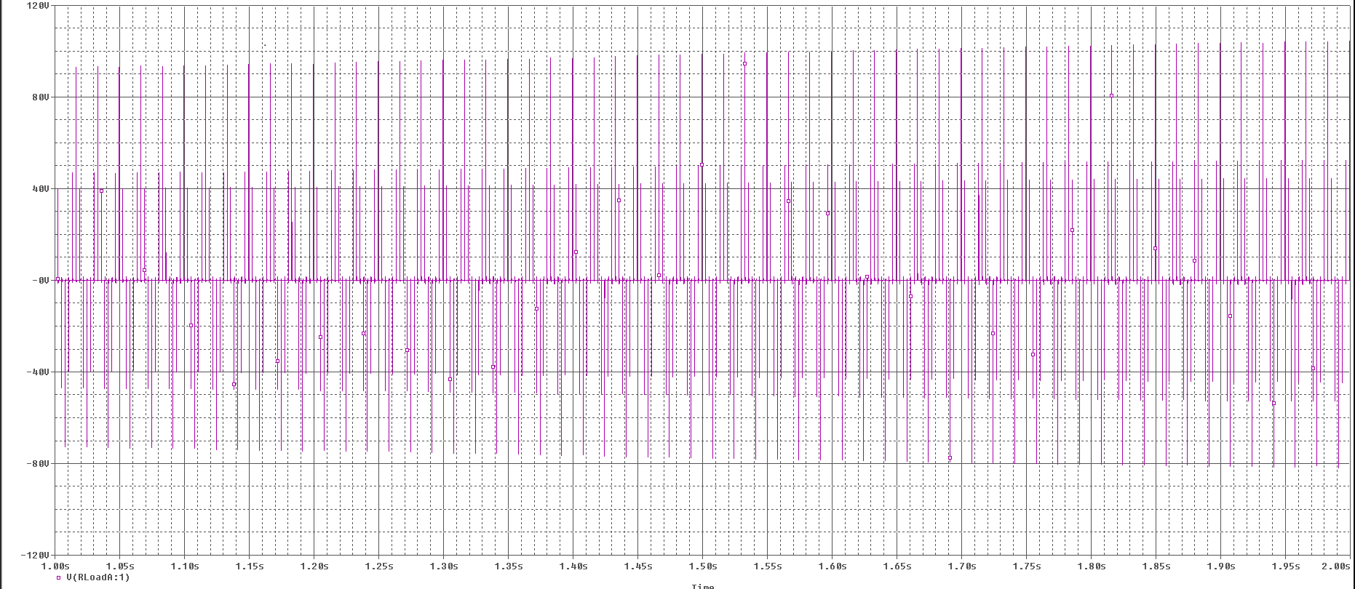

Figure 13: Load Voltages (A) vs. Time with Filter

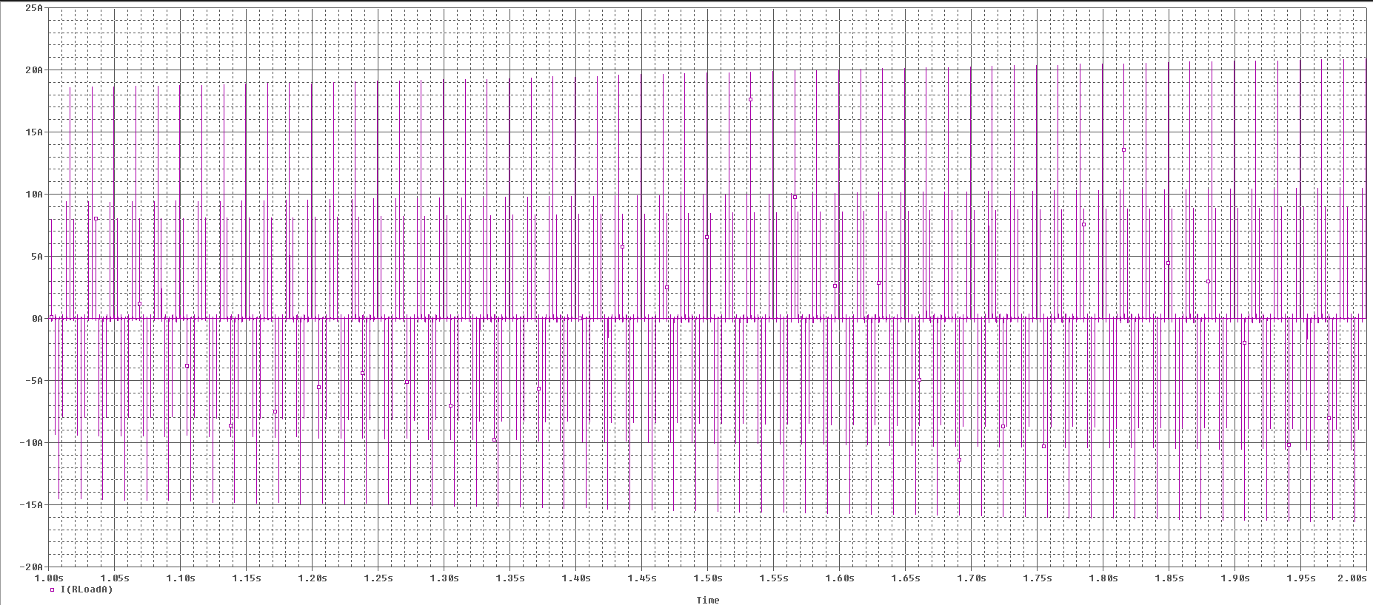

Figure 14: Load Current (A,) vs. Time with Filter